# CS 340 README

## About

Grazioso Salvare international rescue-animal training company. As part of its work, Grazioso Salvare identifies dogs that are good candidates for search-and-rescue training. When trained, these dogs are able to find and help to rescue humans or other animals, often in life-threatening conditions. To help identify dogs for training, Grazioso Salvare has reached an agreement with a non-profit agency that operates five animal shelters in the region around Austin, Texas. This non-profit agency will provide Grazioso Salvare with data from their shelters.

## Motivation

* Develops database queries that match the required filter functionality and utilize the previous CRUD Python module for direct MongoDB access.
* Creates interactive options that allow for the selection of data based on filtering functions and the control of other dashboard widgets, and demonstrates successful executions by providing screenshots with a unique identifier.
* Creates an interactive data table that responds to input from other controls, and demonstrates successful executions by providing screenshots with a unique identifier.
* Creates charts to display data in response to inputs from other controls, and demonstrates successful executions by providing screenshots with a unique identifier.

## Getting Started

The AAC database has the animals collection. There is admin and user authentication to the database with different privileges. I created Create and Read functions for the database that allows me to insert data into the collection and then uses the find function.

## Installation and Tools

MongoDB, Python 3+/Jupyter, and PyMongo driver

## Usage

Installing MongoDB, installing/importing the (csv) data, setting up user authentication, implementing CRUD operations as a Python module, and building an app that uses the CRUD module are all stages in duplicating the project.

## Screenshots

# starting state of dashboard

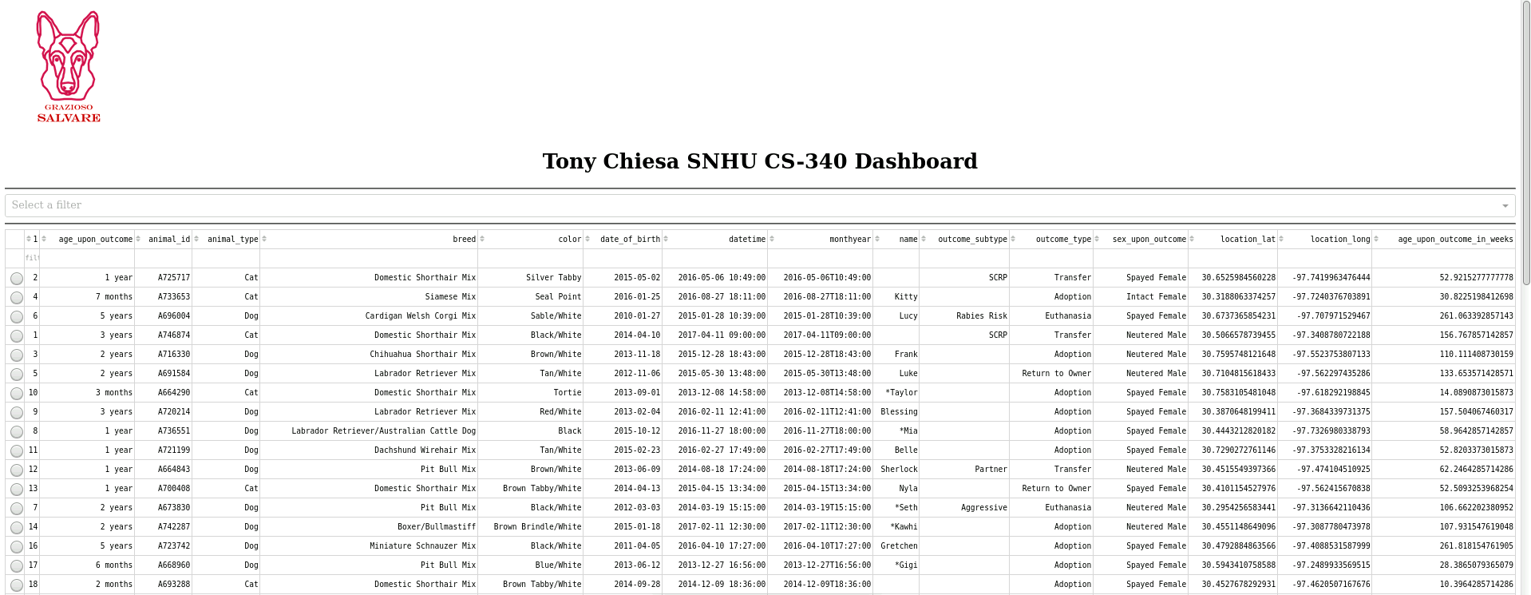

# starting state of widgets

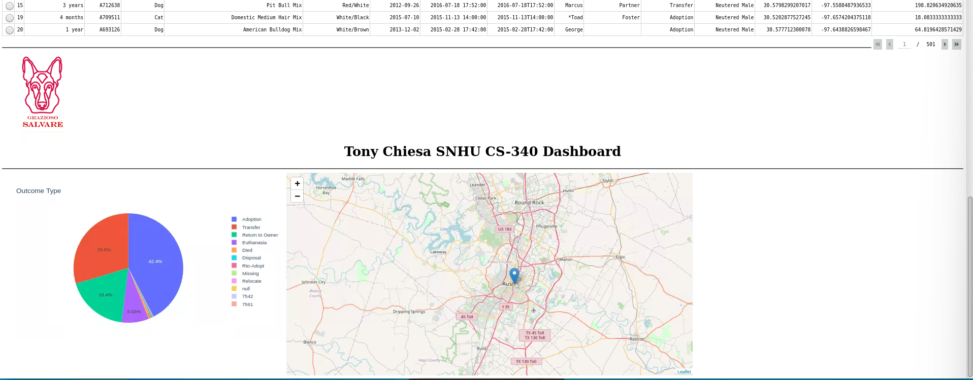

#drop down

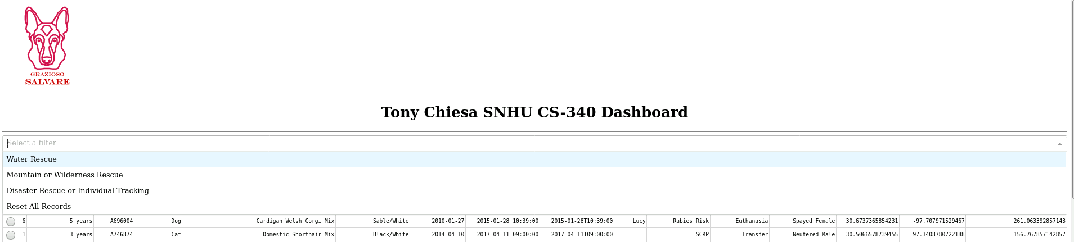

# water rescue filter

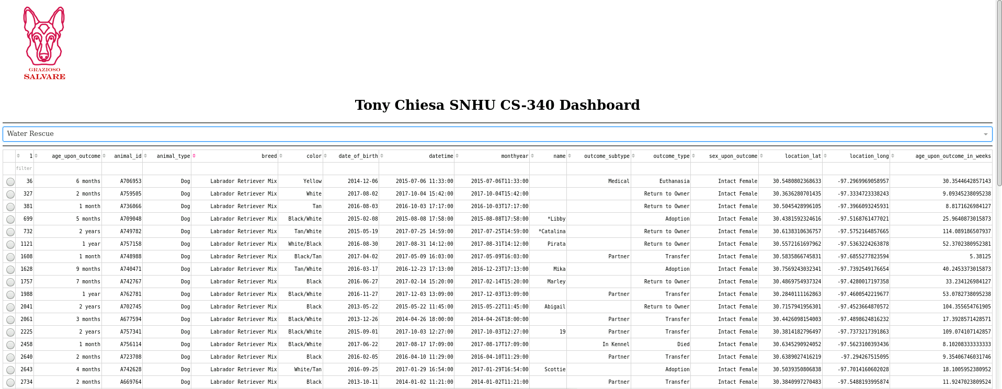

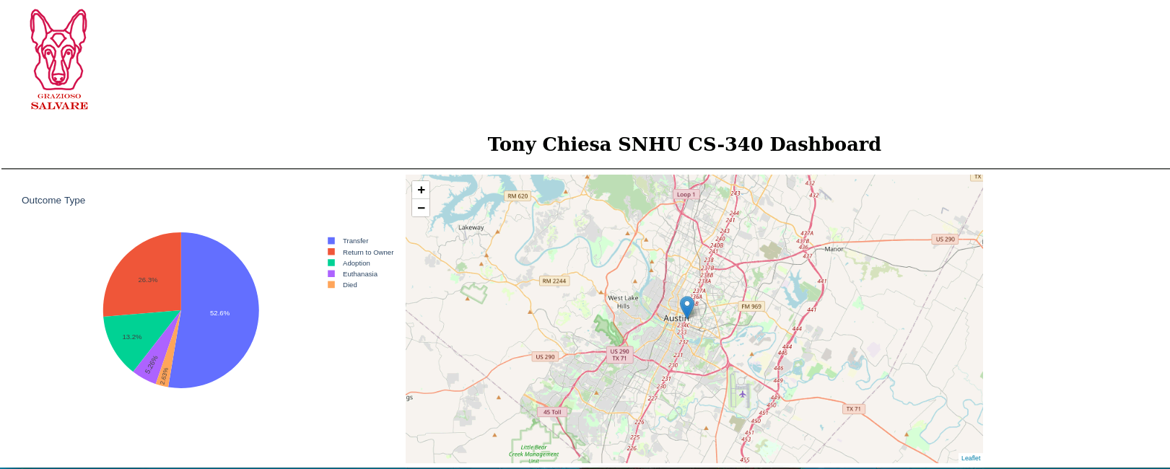

# mountain or wilderness rescue filter

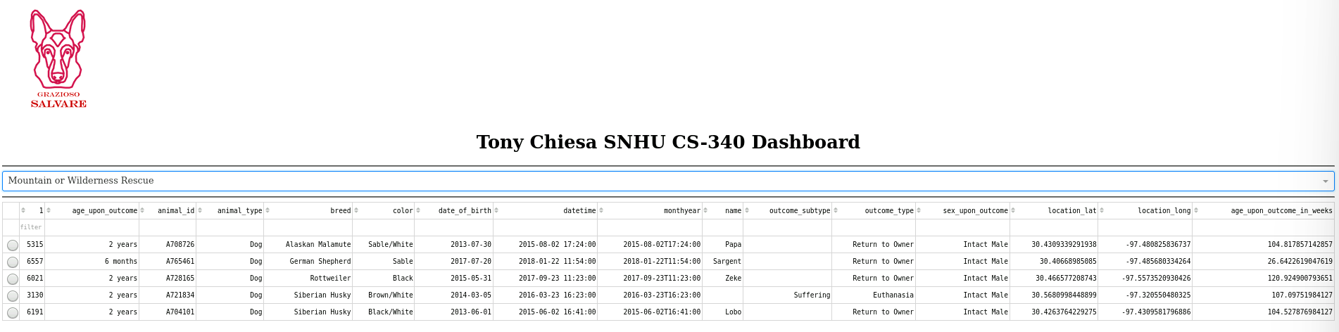

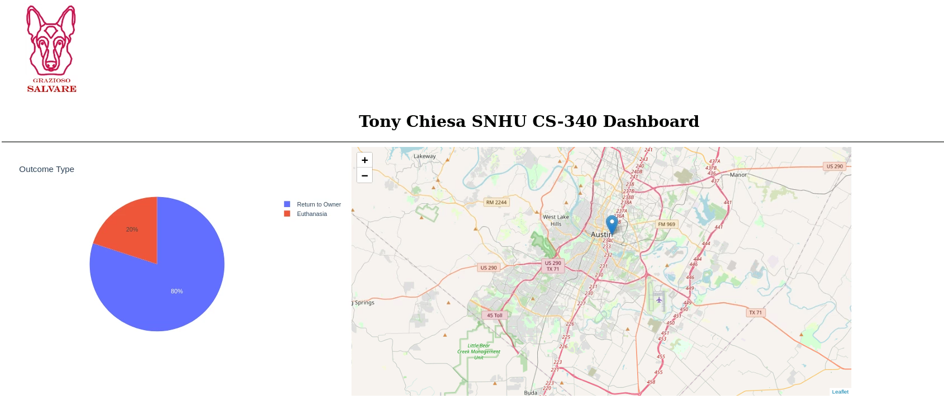

# disaster filter

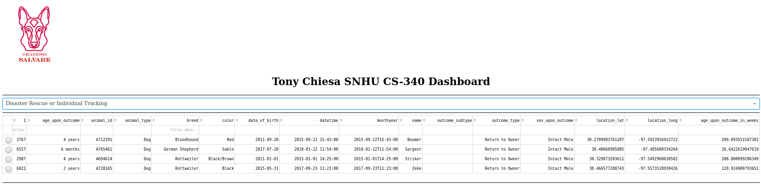

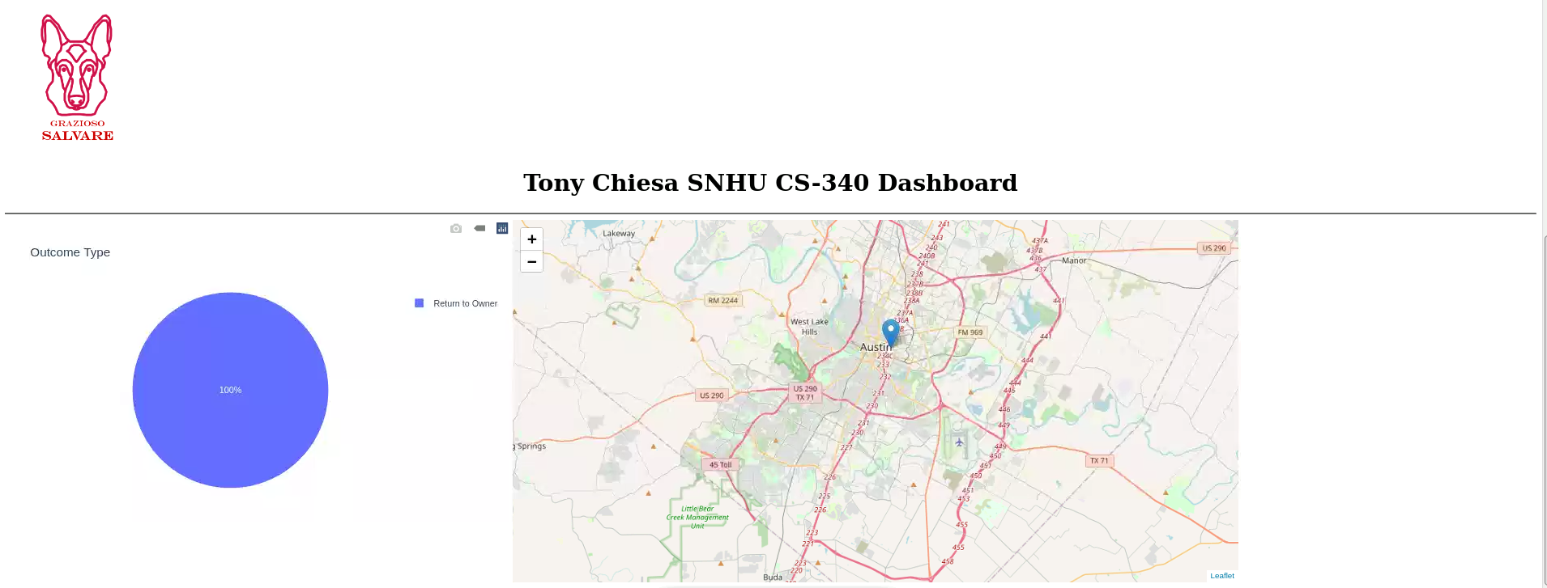

# reset filter

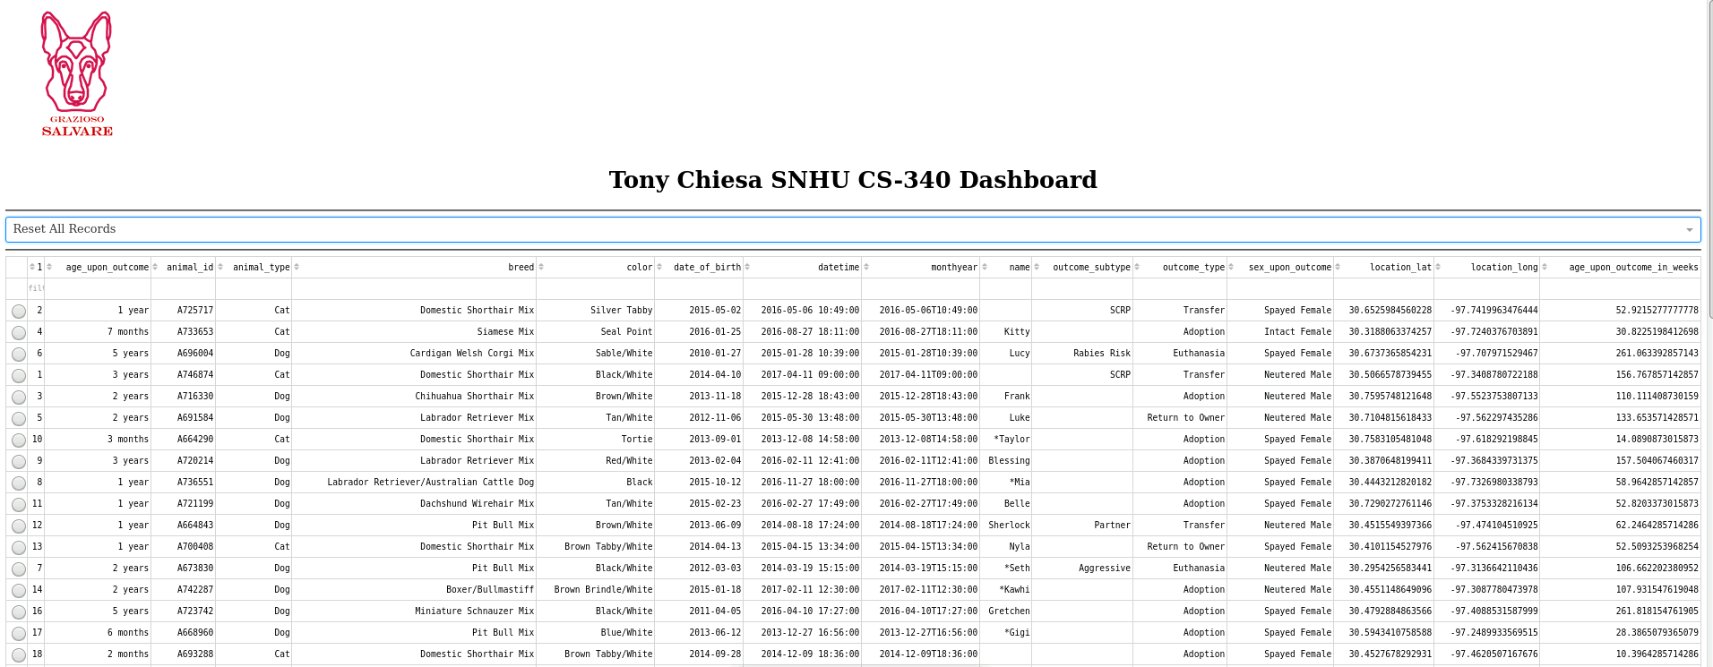

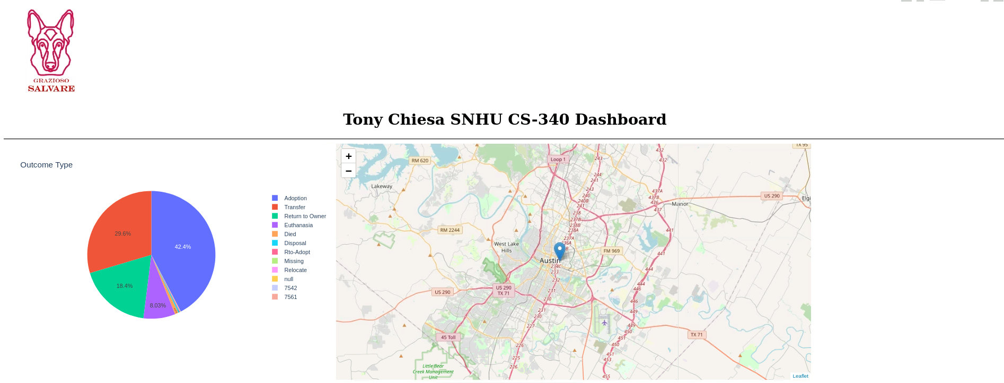

# selected animal and map of selected animal with pop-ups

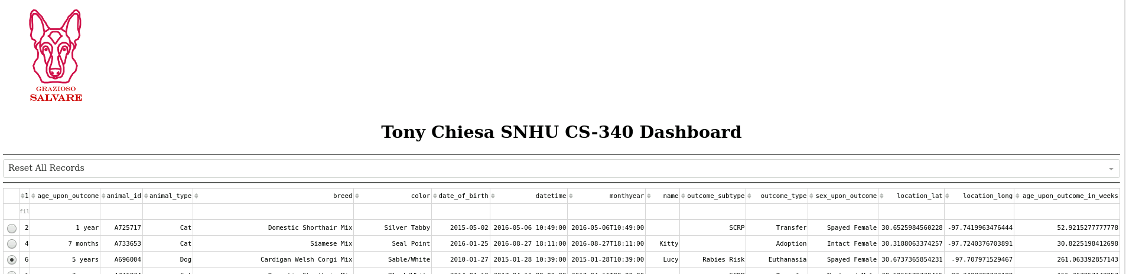

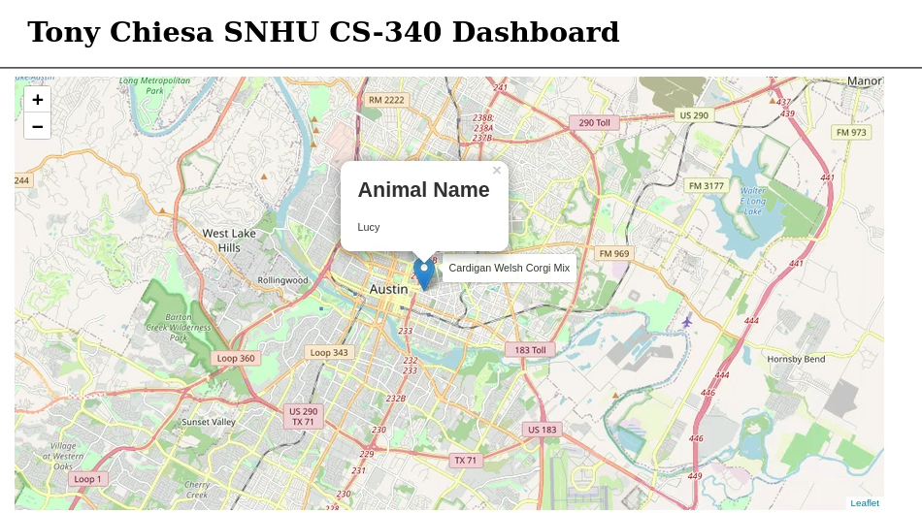

## Usage

### Screenshots

*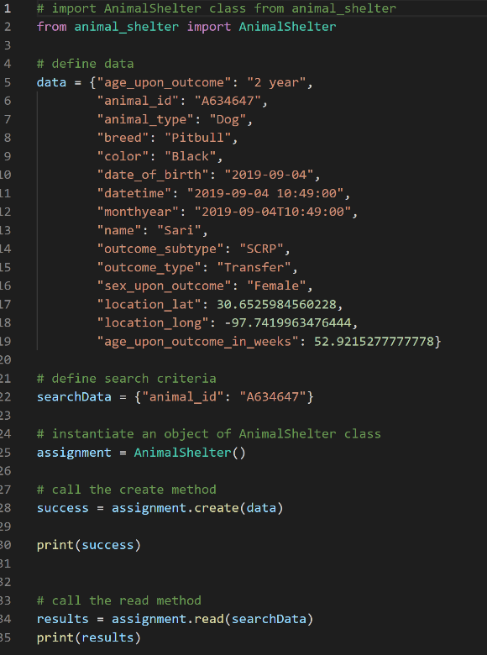***#script.py #animal_shelter.py**

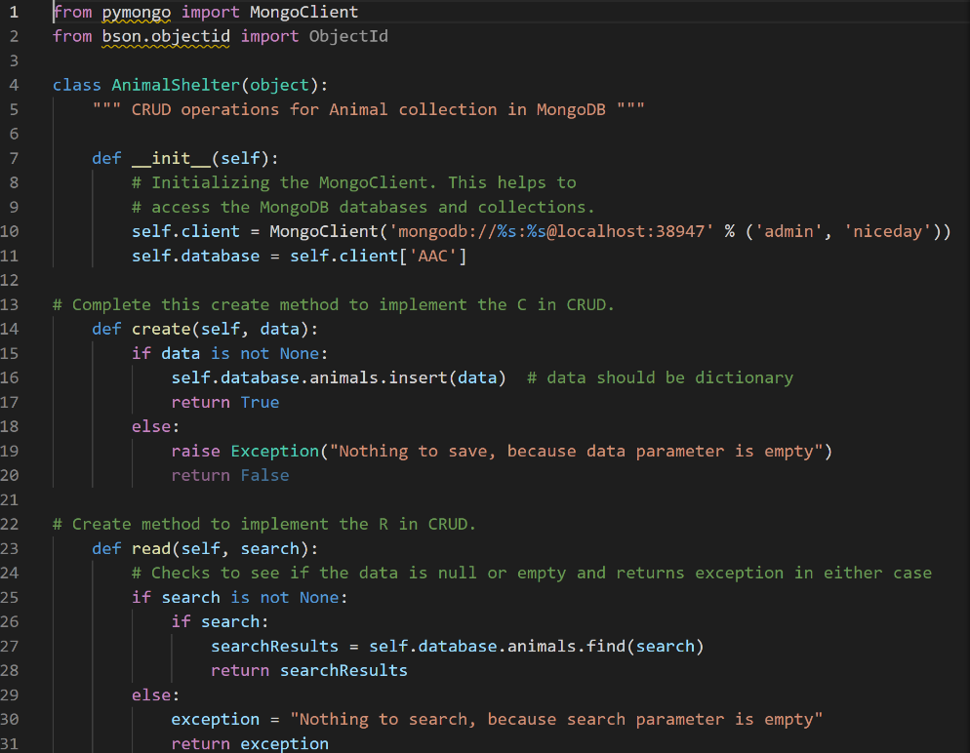

## Contact

Your name: Tony Chiesa